Lifecycle of Docker Container

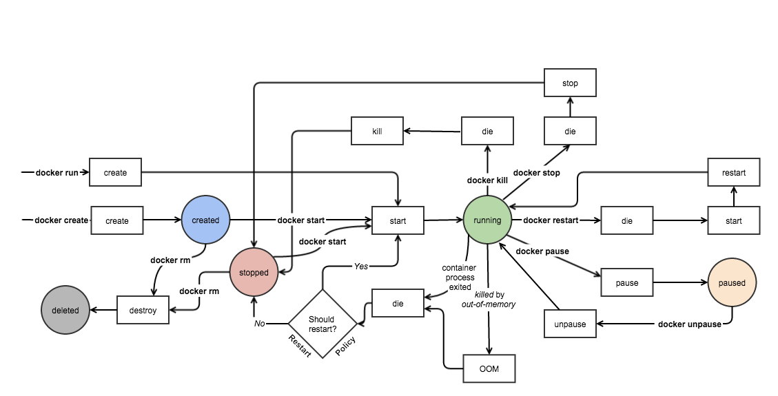

Image Source and Credits: <http://docker-saigon.github.io/post/Docker-Internals/>

Though the above pic is self explanatory, we’ll just discuss the basics / CLI commands for working with docker containers.

**Create container**

Create a container to run it later on with required image.

docker create --name <container-name> <image-name>

**Run docker container**

Run the docker container with the required image and specified command / process. ‘-d’ flag is used for running the container in background.

docker run -it -d --name <container-name> <image-name> bash

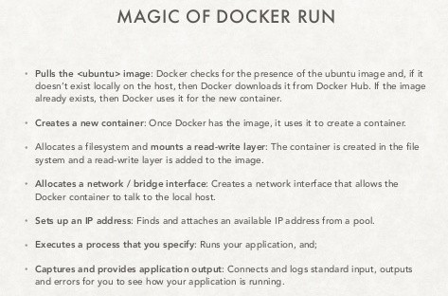

Image Source and Credits: <http://www.slideshare.net/w_akram/docker-introduction-59904719>

**Pause container**

Used to pause the processes running inside the container.

docker pause <container-id/name>

**Unpause container**

Used to unpause the processes inside the container.

docker unpause <container-id/name>

**Start container**

Start the container, if present in stopped state.

docker start <container-id/name>

**Stop container**

To stop the container and processes running inside the container:

docker stop <container-id/name>

To stop all the running docker containers

*docker stop $(docker ps -a -q)*

**Restart container**

It is used to restart the container as well as processes running inside the container.

docker restart <container-id/name>

**Kill container**

We can kill the running container.

docker kill <container-id/name>

**Destroy container**

Its preferred to destroy container, only if present in stopped state instead of forcefully destroying the running container.

docker rm <container-id/name>

To remove all the stopped docker containers

*docker rm $(docker ps -q -f status=exited)*